Lab 5 – Building A Movie Detail App With Navigation
1. Objective
In this lab, students will design and implement a simple Movie Detail App that demonstrates how to use Flutter’s navigation mechanisms (Navigator.push, MaterialPageRoute, or named routes) and basic UI composition.
The project reinforces the key ideas from Module 5 – Navigation & State Management.
2. Requirements
Create a two-screen Flutter application:
- Home Screen – displays a scrollable list of movies (poster, title, and rating).
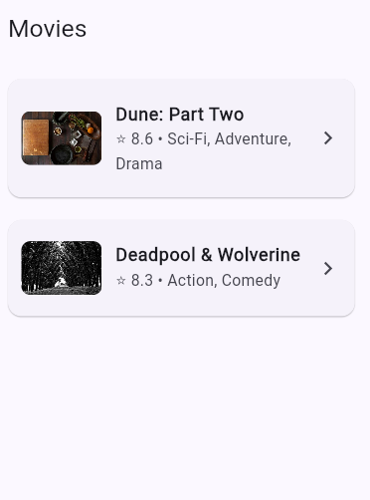
- Movie Detail Screen – shows the selected movie’s information, including:
  - Poster (Hero banner with gradient)
  - Title and genres displayed as chips
  - Overview text
  - Action buttons (Favorite / Rate / Share)
  - List of trailers
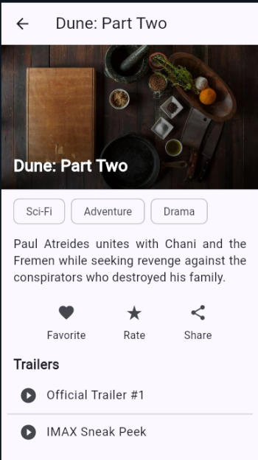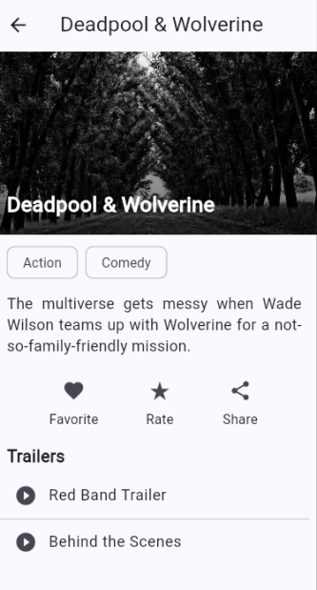

Technical Requirements
- Navigation must use either
  - Navigator.push + MaterialPageRoute, or
  - Named routes (Navigator.pushNamed).
- Pass a Movie object between screens.
- Layout should be scrollable and responsive.
- Use static sample data (no API calls).
- The app must run correctly in DartPad and Android Studio / VS Code.
Optional Enhancements
- Implement a Favorite toggle that updates state.
- Add a simple search bar to filter movies.
- (Advanced) Experiment with a deep-link that opens a specific movie detail page.

3. Guided Steps
Step 1 – Project Setup
Create a new Flutter project (flutter create movie_app) or open DartPad Flutter.
Step 2 – Define Data Model
Create a Movie class with fields for id, title, posterUrl, overview, genres, rating, and a list of Trailers.
Add a sample_data.dart file containing 2–3 movie objects.
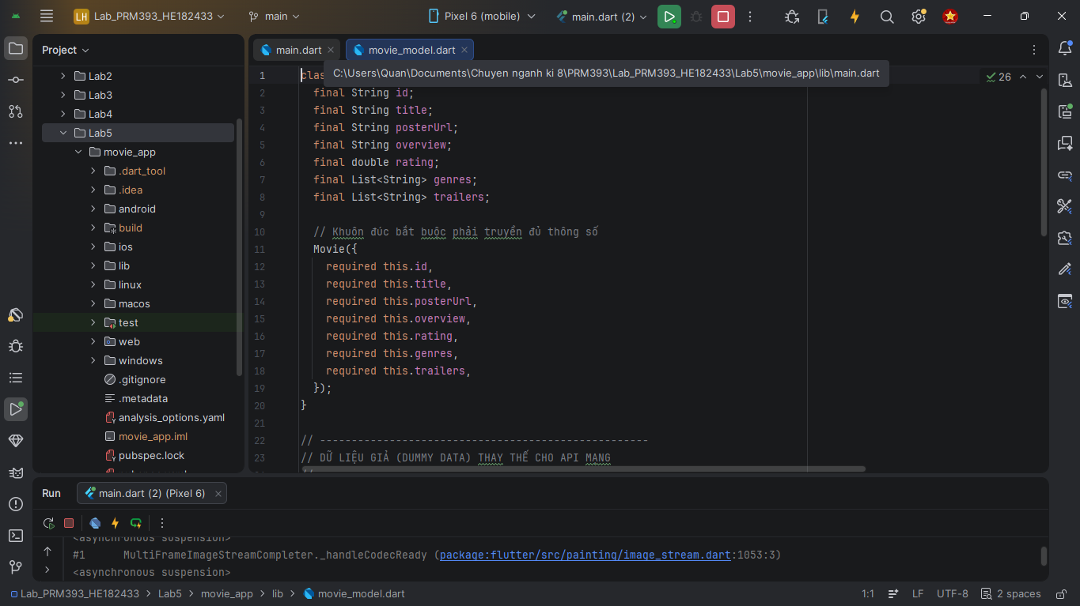
Step 3 – Build Home Screen
Use ListView.builder to display each movie card.
On tap → navigate to Movie Detail screen, passing the selected object.
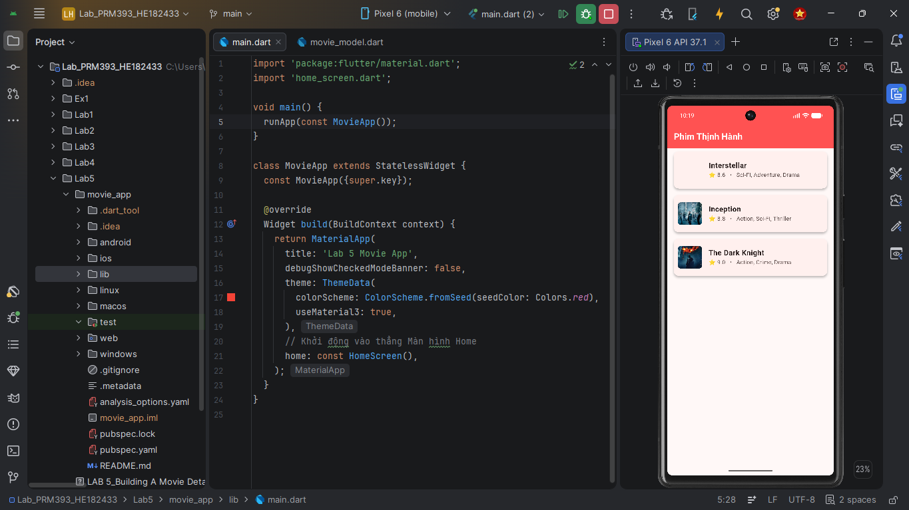
Step 4 – Build Movie Detail Screen
Compose the UI progressively:
- Blank Scaffold + AppBar
- Hero Banner (Stack + Image.network + gradient)
- Title & Genres (Column + Wrap + Chip)
- Overview text with Padding
- Row of IconButtons (Favorite, Rate, Share)
- Trailer list using ListView.builder
Step 5 – Test and Polish
Run the app → check navigation works and UI scrolls smoothly.
Optionally add state management with setState() or ChangeNotifier.
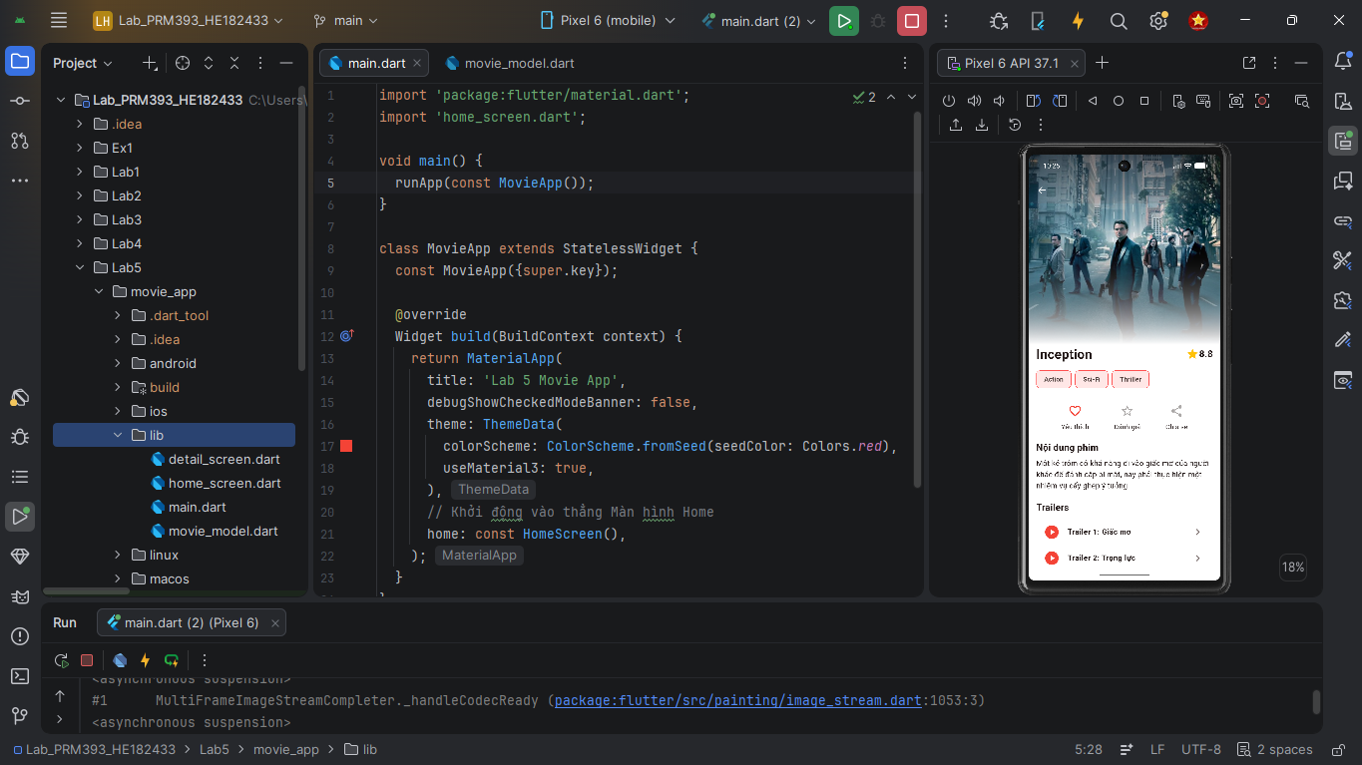
4. Expected Result
When finished, the app should:
- Display a movie list on Home.
- Navigate to a detail page with poster, genres, overview, actions, and trailers.
- Return to Home using the Back button.
- Match the Demo Progress sequence in Figures 8.12 – 8.18 of Mastering Flutter 2025.
5. Submission
- Deliverable: Zipped Flutter project or DartPad share link.
- Evaluation Criteria:
  - Correct navigation logic (30%)
  - UI layout & design consistency (30%)
  - Functionality & state handling (25%)
  - Code clarity & comments (15%)

